Wackronyms App (wAPPronyms?)

- Main screen
  - Create Match Button
    - Enter player name
    - Go to lobby
  - Join Match Button
    - Enter join code
    - Enter player name (Black text)
    - Go to lobby
  - Interface with keypad to enter responses and display/edit them on the screen
    - Browser's job
- Lobby – join code displayed at the top
  - Min/max players
    - 3 - 8
  - Player colors
    - Random color assigned at join
    - Make player-selectable is future development
    - Text is identifiable as being from this player when it is this color from here on
  - Player name – editable at this stage?
- Gameplay
  - Pseudo-random letters / length selected and revealed
    - Frequency of more common letters increased; some left out
  - Prompts – pseudo-randomly select each time from master prompt list
    - Ensure no duplicates within a session
  - Interface with keypad to enter responses and display/edit them on the screen
    - The web browser should handle this
  - Submit button
  - Bonus point for first submission
    - Is there a penalty for the last submission? Or a timer?
  - Read each response one by one (random order)
    - Black text
  - Display all responses at once for the vote
    - Black text
    - Prompt, “Tap your favorite response”
    - Highlight selection
    - Submit button
  - Voting results screen
    - Starts with all responses as in the voting screen
    - “Votes” text above a number box in lower right-hand corner of each submission
    - Ones that didn’t receive votes are greyed out
      - Red “X” / number “0” shown in vote boxes?
      - Raspberry / buzzer sound effect?
    - Number displayed in the votes boxes of the remaining submission start with 1 then increase one at a time before settling at the respective number of votes received
      - Ding / tabulation sound effect as numbers increase
    - Submissions are sorted on the screen in descending order of votes received.
    - The submission with the top number of votes is celebrated by the game
      - Highlighted
      - Wavy lines drawn around it
      - Cheering sound effect
    - Winning submission’s author revealed
      - Labelled with their name
      - Text changes to their color
    - All folks who voted for this one are revealed
      - Each is given a point
    - Each submissions’ author is revealed
  - Go to score screen
    - Show each player’s scores in each category for each round
      - First submission
      - Voted for most popular
      - Number of votes
      - Round subtotal
      - Total (sum of round subtotals)
        - Stands out – bigger text, slightly offset
        - Players ordered by total score
  - Is it the last round:
    - How many rounds?
    - Yes: Declare winner with more celebrations
      - Crown drawn on
      - “Play again with same players” button
    - No: Begin next round
- Screen transitions
- Matchmaking – future development
- Music
- Sound effects
  - cheering (mentioned earlier)
- Platform options
  - MIT App Inventor
  - Android studio
  - Other
- Engine options
  - Create my own (Time/labor intensive)
  - Open source available online – these are cross-platform
    - pygame – simple; has some long-time unfixed bugs to work around
      - OcempGUI – Uses pygame and provides simple OOTB solution elements
        - http://ocemp.sourceforge.net/gui.html
    - pyjs – compile python into js packaged application for web deployment
    - pyjamas – what a lot of people are using for pyjs applications
    - DO NOT NEED mobile support – the options below would help with Android/iOS, but I'll just need a hosted web application.
    - Kivy: iOS build tools require python 2.7
    - BeeWare: This one looks more promising: https://www.activestate.com/blog/the-best-python-frameworks-for-mobile-development-and-how-to-use-them/
  - Pay for one
- Process to release to the android store
  - App cost? Ads?
- Port to Apple store as well – future development
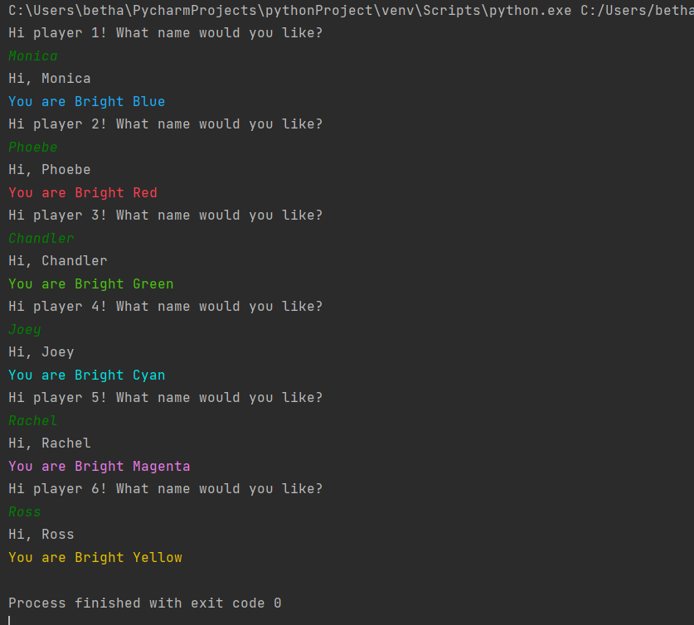
- Intellectual property rights at some point.

